**LANGUAGE IN BELGIUM**

**https://24x7offshoring.com/**

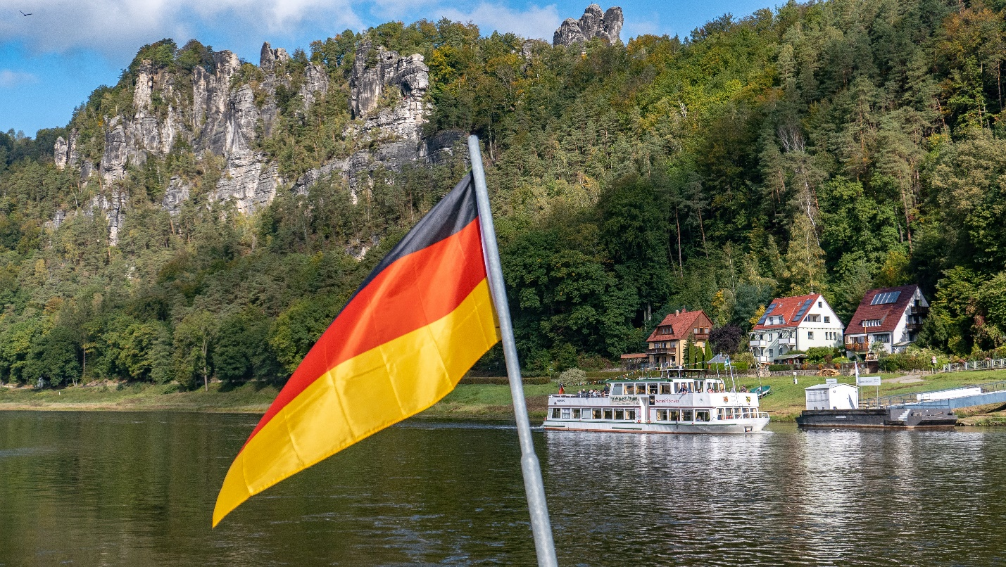[**http://24x7outsourcing.com/**](http://24x7outsourcing.com/)

**What Language Is Spoken in Belgium?**

Belgium is renowned for being the thumping heart of the European Union, while foodies likewise run there to make the most of its chocolate, waffles, brew and that's just the beginning. Yet, what language is spoken in Belgium?

What's more, for what reason is it so natural to outrage somebody by talking 'some unacceptable' language in Belgium? Peruse on to discover!

Belgium is settled between France, Germany and the Netherlands, in Western Europe. Covering around 30,000 square kilometers, it is a generally little country and furthermore quite possibly the most thickly populated on the landmass.

Practically the entirety of Belgium's 12 million occupants talk at least one of these dialects, while some 38-55% of the populace (gauges change) likewise communicate in English as a subsequent language (or sometimes, third or fourth).

Flemish Dutch is the most discussed the three dialects, with around 59% of the populace talking this as their essential language. French is spoken by around 40% of Belgians as their essential tongue, while only 1% of the populace communicates in German as their first language.

**Official Languages of Belgium**

It is safe to say that you are searching for realities about the language in Belgium? Provided that this is true, you're in the correct spot. There isn't only one authority language of Belgium, yet three: Flemish Dutch, French and German.

That is notwithstanding under 1% of Belgians communicating in German as their essential tongue.

**Flemish Dutch**

What language do they talk in Belgium? Alluded to as Flemish by local people (and large numbers of those outside of Belgium too), the Dutch verbally expressed in Belgium is like that spoken in the Netherlands, however for certain prominent contrasts in jargon and articulation.

Flemish Dutch is the most discussed Belgium's three authority dialects and is revered in law, alongside French and German, however the country's constitution doesn't expressly make reference to explicit dialects.

It is communicated in as an essential language by around 6.5 million inhabitants, the greater part of them situated in the northern locale of Flanders.

**French**

What dialects do Belgians talk outside of the north of the country? Fundamentally French.

It is the second public language of Belgium regarding speaker numbers, with 4.5 million individuals utilizing French as their first language.

The greater part of Belgium's French speakers are situated in the southern Wallonia locale, just as in the capital, Brussels. This is regardless of Brussels being in the Flemish-speaking Flanders locale (we take a gander at the dialects verbally expressed in various areas of Belgium beneath).

The French verbally expressed in Belgium is generally like that spoken in France, however there are particular contrasts in jargon and elocution, similarly as there are between Flemish Dutch and Standard Dutch.

These distinctions are particular enough that you would unquestionably need to utilize an interpreter living in Belgium as opposed to France in the event that you were giving English to French interpretation administrations for a customer working together in Belgium.

**German**

The Belgian public language with the least speakers is German. For this language, Belgium is home to only 75,000 essential language speakers, practically every one of whom dwell in the eastern area of Liege, arranged close to Belgium's line with Germany.

**LANGUAGE IN BELGIUM**

**https://24x7offshoring.com/**

**http://24x7outsourcing.com/**